**The Lute Fantasias of Melchiore de Barberiis da Padova**

Melchiore/Merchiore/Marchiore de Barberiis was a priest and amateur musician in Padua who composed or more likely arranged the lute music for five of the ten prints in a series published by Girolamo Scotto between 1545 and 1549.[1] The prints include two duos (no 1 & 4) and 24 fantasias (no 2-3, 5-26 here), plus four guitar fantasias. A concordance for one of the vocal intabulations in Barberiis’ fourth book is also found with the title Recercar in another lute print from the same year containing music by Domenicho Bianchini, and so both are included here as no 27 a & b. No 20a is a parody on a vocal model by Verdelot, which precedes it in Barberiis X (no 20b), and no 6a is a parody on Josquin’s Adieu mes amours, and a lute intabulation of the vocal model is included here for comparison (no 6b). The fantasias are generally not of a high standard except for parodies or pastiches of fantasias by Marco Dall’Aquila (no 17a) and Francesco da Milano (no 22a), a version of the originals also included here for comparison (no 17b & 21b). No 18 is in discordatura tuning (sixth course tuned down a tone to F for a lute in nominal G pitch), and no 23-25 employ non-standard tunings, included here both in the original tuning and transcribed into renaissance tuning. No 23 requires the fifth and sixth courses tuned down a tone (one of the variant tunings used in Dalza’s print of 1508), no 24 requires courses 3 to 6 tuned down a tone, and no 25 requires the fourth and fifth courses tuned up a tone. No 14 is in two parts, and no 26 in three. No 21 is a duet for two lutes a tuned in unison. The music is retrospective in character, such as no 12 which employs sequences typical of the recercars in Petrucci’s books of the music of Francesco Spinacino, and as Barberiis parodied Marco and Francesco as well as vocal models by others, one wonders how much of the music is parody of earlier lute music now lost rather than composed himself. The music is transcribed here from Italian into French tablature including the original hold signs (#, not always making sense) and dots under tablature letters to indicate notes to be struck by the right hand index finger, or chords struck upwards with fingers only. Editorial changes appear in the tablature in grey, usually wrong rhythm signs or missing and notes absent or placed on the wrong stave line.[2]

**Barberiis’ prints**

**Libro IV** [4 fantasias] – *Intabulatura di Lauto Libro Quarto de la messa di Antonio Fevino sopra Ave Maria. Intabulata & accomodata per sonare sopra il Lautto dal Reverendo messer pre Marchiore de barberiis da Padova sonatore excellentissimo de Lautto, da lui proprio nouamente à utilità di virtuosi posta in luce, con alcuni altri suoi recercari accomodati sopra il tuono di ditta messa. Agiontoui il nuouo modo di accordare il Lautto posto in fine* (Venezia, Scotto, 1546) dedicated to M. Francesco Pisani Cardinali di San Marco - Brown 15462,[3] unique copy in GB-Lbl [K.1.c.14a]

**Libro V** [4 fantasias] – *Intabulatura di Lautto Libro Quinto de Madrigali, et canzon Francese intabulati & accomodati per sonare sopra il Lautto dal Reverendo messer pre Merchiore de barberiis da Padova sonatore excellentissimo de Lautto da lui proprio nouamente à utilità di virtuosi posta in luce. Agiontoui il nuouo modo di accordare il Lautto posto in fine* (Venezia, Scotto, 1546), dedicated to M. Marcantonio da Genova Philosopho Padoano - Brown 15463 unique copy in D-LEm.

**Libro VI** [0 fantasias] – *Intabulatura di Lautto Libro Sesto de diversi Motetti a quatro voce, intabulati, & accomodati per sonare sopra il Lautto dal Reverendo messer pre Merchiore de barberiis da Padova sonatore excellentissimo de Lautto da lui proprio nouamente à utilità di virtuosi posta in luce. Agiontoui il nuouo modo di accordare il Lautto posto in fine* (Venezia, Scotto, 1546) dedicated to M. Marco Mantoa Jurisconsulato Padoano - Brown 15464 unique copy in D-W.

**Libro IX** [4 fantasias] – *Intabolatura di Lauto Libro Nono intitolato il Bembo, di fantasie, balli, passi e mezi, e padoane gagliarde, Composte per il Reverendo M. pre Melchioro de Barberis Padoano, Musico, & sonator di Lauto excellentissimo. Agiontoui il nuouo modo di accordare il Lautto posto in fine* (Venezia, Scotto, 1549), dedicated to Signor Torquato Bembo - Brown 15491 copies in A-Wn and US-Wc.

**Libro X** [13 fantasias] – *Opera Intitolato contina, intabolatura di Lauto di fantasie, motetti, canzoni, discordate a varii modi, fantasie per sonar un solo con uno Lauto, & farsi tenore & soprano: Madrigali per sonar a dui Lauti: Fantasie per sonar a dui Lauti: Fantasie per sonar sopra la Chitara da sette corde. Composta per il Reverendo M. pre Melchioro de Barberis Padoano, Musico, & sonator di Lauto excellentissimo. Libro Decimo* (Venezia, Scotto, 1549) dedicated to Herculi A Sancto Bonifacio patrono - Brown 15492 copies in A-Wn, D-W and GB-Lbl [shelf mark K.7.c.20].

**Worklist**

1. Barberiis IV, ff. 19v-20v *Duo*

2. Barberiis IV, ff. 20v-21r *Fantasia*

3. Barberiis IV, ff. 21r-21v *Fantasia*

4. Barberiis IV, f. 22r *Crucifizus Carpentias in duo*

5. Barberiis IV, ff. 22v-23r *Fantasia*

6a. Barberiis V, ff. 9v-10v *Fantasia*

6b. Drusina *Tabulatura* 1556, sigs. c3vc4v *Adiu mes amours* [Josquin][4]

7. Barberiis V, ff. 11r-12r *Fantasia*

8. Barberiis V, f. 12r-13v *Fantasia*

9. Barberiis V, f. 13v-14r *Fantasia*

10. Barberiis IX, sigs. f1r-f1v *Fantasia*

11. Barberiis IX, sigs. f1v-f2v *Fantasia*

12. Barberiis IX, sigs. f4r-g1r *Fantasia*

13. Barberiis IX, sigs. g1r-g2r *Fantasia*

14i. Barberiis X, sigs. Aa2v-Aa3r *Recercada*

14ii. Barberiis X, sigs. Aa3r-Aa3v *Fantasia Seconda parte*

15. Barberiis X, sigs. Cc2r-Cc2v *Fantasia*

16. Barberiis X, sigs. Cc2v-Cc3v *Fantasia*

17a. Barberiis X, sigs. Cc3v-Cc4r *Fantasia[5]*

17b. Castelioni *Intabolatura de Leuto* 1536, ff. 29r-30v *Fantasia de M. Marcho Da Laquila* = Gerle *Eyn Newes sehr Künstliches Lautenbuch* 1552, sigs. L4r-M2r *Das 31. Preambel Marx vom Adler*

18. Barberiis X, sig. Dd1r *Fantasia*

19. Barberiis X, sigs. Dd1r-Dd2r *Fantasia Discorda il Basso con il Tenore unisono*

20i. Barberiis X, sigs. Dd4r-Ee1v *Fantasia sopra Se mai prouasti donna*

20ii. Barberiis X, sigs. Dd3v-Dd4r *Madrigale Se mai prouasti donna*

[*Intavolatura de li madrigali di Verdelotto* 1536, ff. 13v-14v *Se mai prouasti donna qual sia amor* [voice and lute, *intavolati per Messer Adriano* (Willaert?)]

21a. Barberiis X, sigs. Ee4v-Ff1r *Fantasia per sonar con dui Lauti on ottavi - Soprano*

21b. Barberiis X, sigs. Ff1r-Ff1v *Fantasia ante scritto per sonare con dui Lauti in ottavi - Tenor*

22a. Barberiis X, sigs. Ff1v-Ff2v *Fantasia*

22b. Gardano *Intabolatura de lauto di Francesco da Milano Libro Primo* 1546, sigs. D3v-D4r *Fantesia di F. da milano* - Ness 28

23a. Barberiis X, sigs. Ff2v-Ff3r *Fantasia per sonar un Lauto, & farsi Tenor & Soprano [6]*

23b. Barberiis X, sigs. Ff2v-Ff3r Fantasia - transposed

24a. Barberiis X, sigs. Ff3r-Ff4r *Fantasia discordata per sonare solo uno*

23b. Barberiis X, sigs. Ff3r-Ff4r Fantasia - transposed

24a. Barberiis X, sigs. Ff3v-Ff4v *Fantasia discordata*

25b. Barberiis X, sig. Ff3v Fantasia - transposed

26i. Barberiis X, sigs. Ff4v-Gg1v *Fantasia. Prima parte*

26ii. Barberiis X, sigs. Gg1v-Gg3r *Fantasia. Seconda parte*

26iii. Barberiis X, sigs. Gg3r-Gg3v *Fantasia. Terza parte*

**Appendix**

27a. Barberiis IV, ff. 17r-17v *Qui tollis peccata* [Richafort][7]

27b. Domenicho Bianchini *Intabolatura de Lauto* Gardane 15465, sig. A4r *Recercar quarto*

*John H Robinson, February 2013*

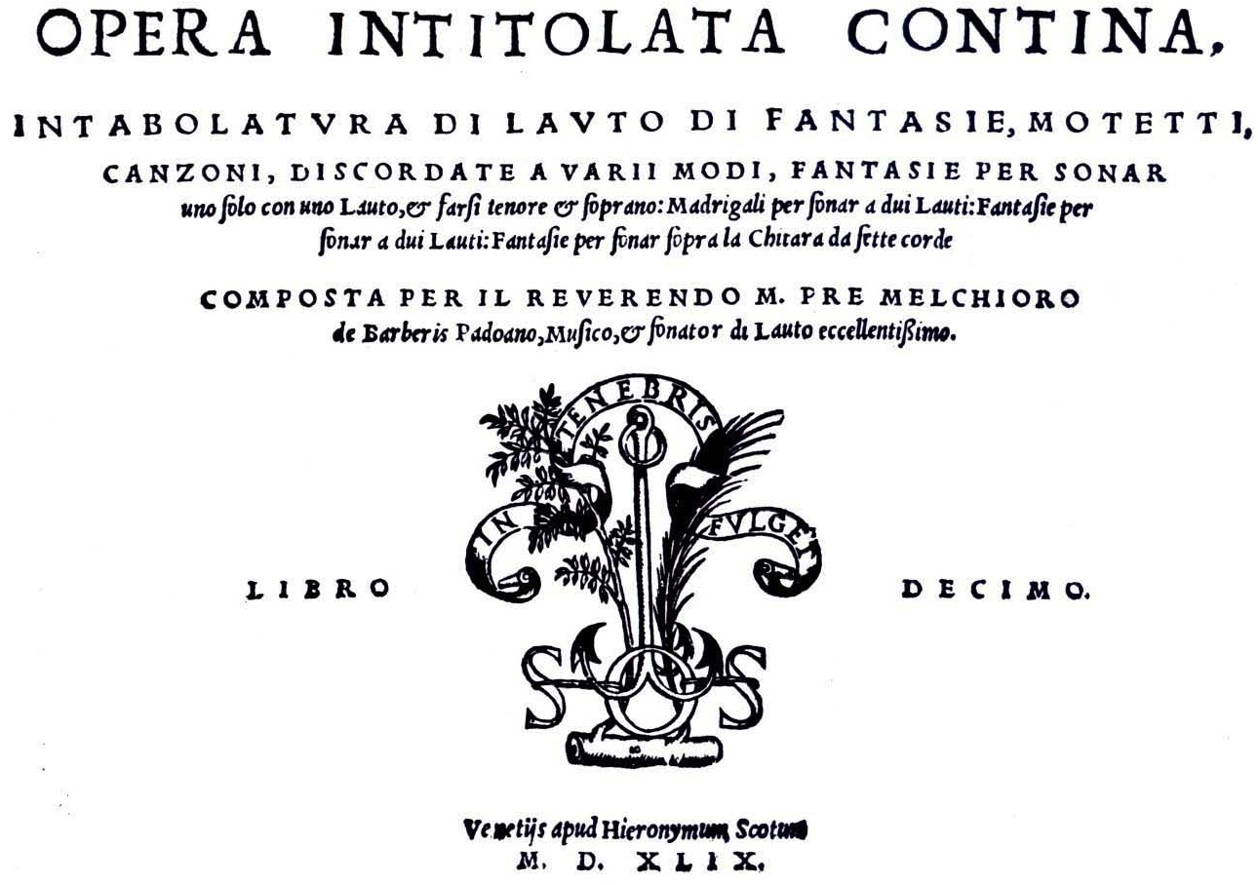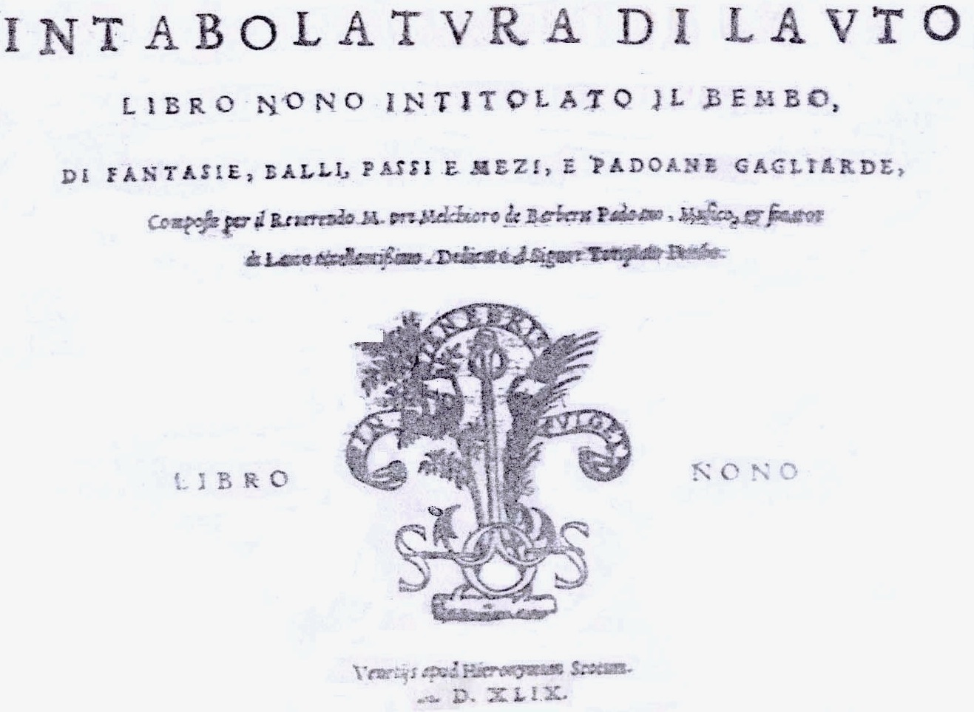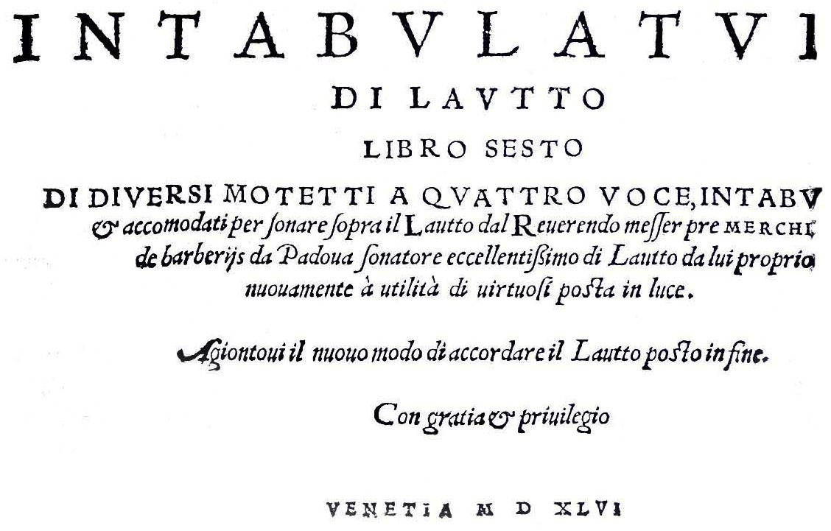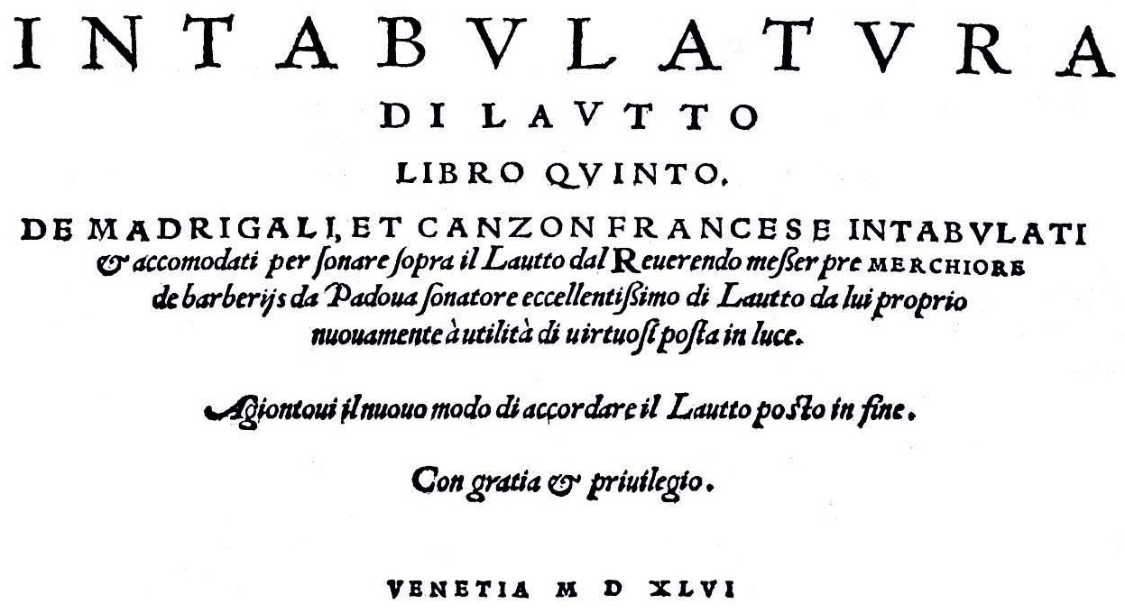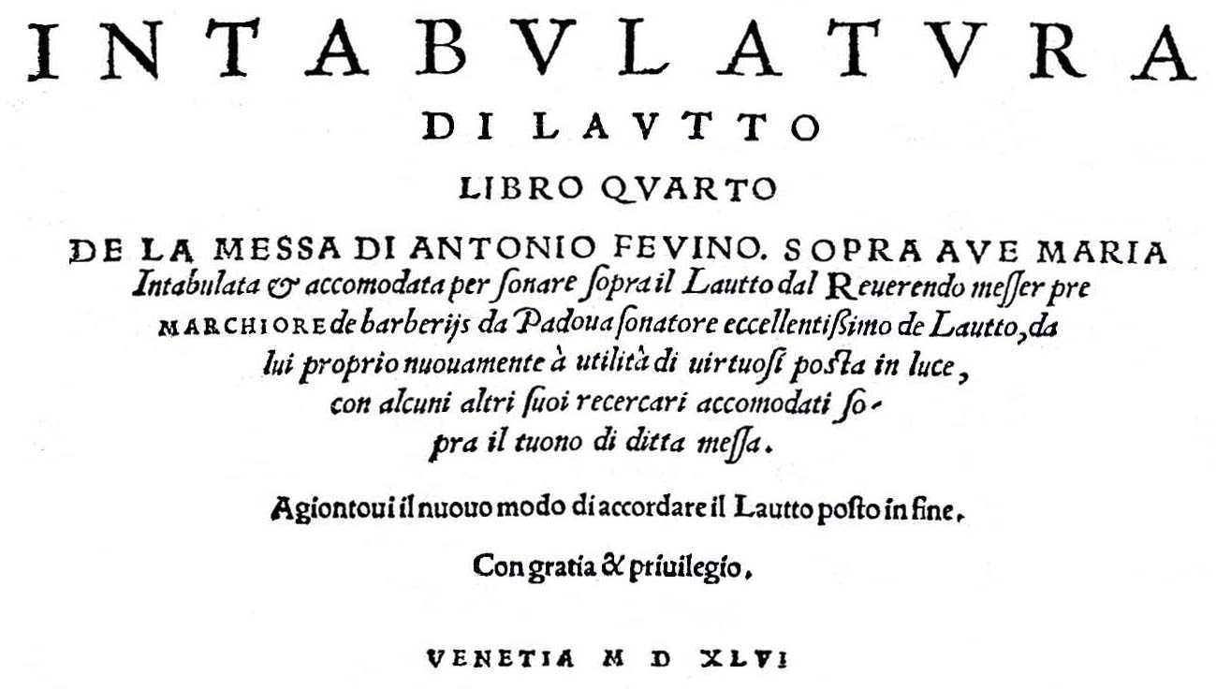

1. A facsimile edition of Barberiis’ Book V was published by Tree Editions in 2002, and digital facsimiles of the British Library copies of Books IV and X can be accessed through Early Music Online:

   <https://repository.royalholloway.ac.uk/items/7b0093b9-66a2-5bf5-be84-7900b757197a/1/> <https://repository.royalholloway.ac.uk/items/4966772d-ff46-ae39-4030-8228291da5a0/1/>

   No modern editions or recordings of Barberiis’ music have been published or released to date. The other volumes in the series are I. Antonio Rotta *Intabolatura de Lauto* 154615; II. Francesco da Milano and Pietro Paulo Borrono *Intabulatura di Lauto* 15468; III. Julio Maria da Crema *Intabolatura de Lauto* 154611; VII. Francesco da Milano *Intabolatura de Lautto* 15484; VIII. Pietro Paulo Borrono *Intavolatura di Lauto* 15482.
2. **Commentary**: **1.** 6/2 d3 absent; 38/1 c3 instead of d3; 42/1 c3 instead of c4; 50/1 minim instead of crotchet; 54/3 c3 instead of a3; 57/3 b4 instead of c4; 59/1 minim instead of crotchet; 64/2 d3 absent; 66/3-4 c4-a4 instead of c5-a5. **2.** 48/1 a5 instead of a6; 56/1 c2 absent; 57/2-7 tablature a line higher; 58/1 tablature a line higher. **3.** 15/7 d3 instead of d2; 18/4 crotchet absent; 27/1 b4 instead of b3; 37/3 quaver absent. **4.** 6/1 minim absent; 24/1 minim absent; 30/1 minim instead of crotchet. **5.** 6/2 crotchet absent; 36/1 d6 instead of c5; 41-42 bar line absent; 55/2 quaver absent. **6a.** 14/3 crotchet a note to the left; 21/3 c3 instead of b3; 54/1 e1e3 instead of e2e4; 70/3 c3 instead of d3. **6b.** 3/1 c1f2c5 instead of h1f2h5; 3/4 d2 instead of d3; 19/5 quaver absent; 35/12 c4 instead of e5; 42/2 e4 instead of a5; 42/4 d2 instead of d3; 42/6 c1 instead of h1. **7.** 1/1-2 quaver instead of crotcher quaver; 2/1 minim instead of crotchet; 68/1 crotchet a note to the right. **8.** 1/1 crotchet rest absent; 10/1 minim absent; 11/2&4 f3 instead of g3; 42/1 c1 instead of a1; 51/2 a2 added; 52/1 d5 instead of d4; 65/2 d4 instead of d3; 67/1 c5 instead of c4; 72/1 e4 instead of d4; 78/1 a2 instead of a1; 82/1-2 crotchet quaver instead of quaver; 82/5-6 crotchet absent. **9.** 41/2 crotchet instead of quaver; 41/4 crotchet absent. **10.** 12/4 crotchet absent; 32/5 a3 instead of b3; 58/4 e4 instead of f4; 64/4 d3 instead of d4. **11.** 26/1 c6 changed to c5; 47/2 h2 changed to f2; 49/1 d3 instead of h3; 50/1 e2 instead of h2; 72/2-4 b4-d4a3 instead of b3-d3-a2. **12.** 25/1 c1 instead of d1; 76/3 c1 instead of d1. **13.** 15/1 minim absent; 19/between 2-3 d2 inserted; 24/5 crotchet inserted before semiquaver; 31/4 dot under note to the left; 55/8 & 56/6 dots absent; 67/2 crotchet instead of quaver; 68/1 crotchet absent. **14i.** 15/2-3 b3-a3 instead of b2-a2; 21/1 e4 instead of d4. **14ii.** 35/1 a1b2d3d4 instead of b1d2d3a4; 48/1 minim absent; 54/2 c3 instead of b3; 54/3 a4 added; 55/2 a3 instead of d4; 56/2 a1 omitted; 60/3 b3 instead of c3. **15.** 12/1 f2 instead of d2; 21/1 crotchet absent; 27/2 d2 instead of d1; 46/2 quaver a note to the right; 70/2 crotchet a note to the right. **16.** 6/1 c3 instead of b3; 7/1 c3 instead of b3; 7/3 d2 instead of c2; 12/3 b2 instead of c2; 19/3 a3 instead of a4; 22/1 d1a2 instead of d2a3; 24/1 c5 added; 36/2 d2 instead of d3. **17a.** 2/2 b3c4 instead of b4c5; 5/4 c4 instead of c5; 22/1 b4c5 instead of b3c4; 28/4 c5 instead of c4; 36/1 a4 instead of a5; 38/1 h2 instead of h3; 50/1 a1 instead of a2; 50 bar duplicated. **17b.** none. **18.** 4/1 c1 instead of d1; 4/3 a2 instead of a1; 12/1 a4 instead of d4; 13/1 b4 instead of b3; 19/3 crotchet a note to the right; 23/1 a5 instead of a4. **19.** 6th course tuned down a tone [from G to F]; 15/2 minim instead of quaver; 25/4 crotchet a note to the right. **20i.** 10/4a5 instead of a6; 18/1-2 quaver-crotchet instead of crotchet-quaver; 28/2 quaver a note to the left; 34/2 quaver a note to the left; 37/1 crotchet instead of dotted crotchet; 43/2 quaver a note to the right. **20ii.** 13/2 d2c3a4 instead of d3c4a5; 15/1 d2 instead of b2; 38/1 a2 instead of b2; 45/1 c4 instead of c5; 45/2 c4 instead of c5; 57/1 crotchet a note to the left. **21a.** 28/2 quaver a note to the right; 28/5 a1 absent. **21b.**22 bar omitted; 24 bar omiited; 33 rhythm signs absent; 41/2 c2 instaed of b2. **22a.** 30/1 printed d1 absent, added by hand. **22b.** 3/3 c2 instead of d2; 54/1 c5 instead of d5; 91/3 a3b4 instead of b3. **23a.** 4/1 a2 instead of d2; 14/1 b2 instaed of c2. **23b.** 4/1 a2 instead of d2; 14/1 b2 instaed of c2. **24a.** 42/2 f1 omitted. **24b.** 25/1 i2 instead of d2; 42/2 f1 omitted. **25a.** 14/1 minim added; 14/2 quaver absent; 15/1 crotchet absent; 38/2 c4 instead of a4. **25b**. 11/4 f2 instead of a1; 14/1 minim added; 14/2 quaver absent; 15/1 crotchet absent; 38/2 e4 instead of c4. **26i.** none. **26ii.** 22/1 quaver instead of crotchet. **26iii.** 20/3 quaver a note to the left. **27a.** 14/1 b4 instead of b3; 61/2 quaver a note to the right; 66 rhythm signs absent. **27b.** 11/7 e4 instead of d4.
3. Howard Meyer Brown *Instrumental Music Printed Before 1600: A Bibliography* (Cambridge MA, Harvard University Press, 1965).
4. Other lute intabulations: D-Mbs Mus.272, ff. 52v-53r *Adieu mes amours*; A-Wn 41950, ff. 5r-5v *Adÿ mes Morß*. Spinacino *Libro primo* 1507, ff. 32v-33v *Adiu mes amours*; Gerle *Tabulatur auff die Laudten* 1533, ff. 39r-40r *Adieu mes amours*; Newsidler *Ein Newgeordent Künstlich Lautenbuch* 1536, sigs. p4v-q2r *Adiu mes amours*; Newsidler *Der ander theil des Lutenbuchs* 1536, sigs. X3v-Y2r *Joß Quin Adiu mes amours*; cf. Valderrabano *Libro de Musica* 1547, ff. 88r-88v *Adiu mes amours* [Mouton].
5. No 17a is entirely made up of a pastiche of sections from Marco’s 17b as follows: [17a=17b] bars 1-8=1-8, 9-12=26-29, 13-28=70-85, 29-37= 92-100, 38-48= 119-129, 49-70=142-162.
6. Tuned the same as Dalza *Intabulatura de Lauto* (Petrucci 1508) ff. 27v-32v *Pavana alla ferrarese, Saltarello, Spingardo*.
7. Reprinted in Bianchini/Gardane 1554, sigs. A4r-A4v *Recercar Quarto*; Bianchini/Scotto 1563, p. 8 *Recercar quarto*. Concordance communicated to me by Jacob Heringman, and identified in Arthur J. Ness ‘Domenico Bianchini : Some recent findings’ in Jean-Michael Vaccaro (ed.) *La Lute et Sa Musique* (Paris, CNRS, 1984). The rececar is played by Richard MacKenzie on the CD *Il Rosetto, Domenicho Bianchini’s Lute Book (1546)*, see: magnatune.com/artists/albums/rmackenzie-bianchini/ [track 22, but it seems to be mislabelled as Recercar Terzo (Duo)].